Turned Tables: Examining Black Voters’ Stereotypes of White People
Julian J. Wamble
George Washington University

Abstract:
Most studies on the political implications of stereotypes have focused on how dominant social groups, like Whites, leverage them against marginalized groups, like Black people. This paper aims to explore the stereotypes that Black people hold about White people, and their utility in navigating social and political spaces. Using data from the General Social Survey and a unique dataset collected by Time Magazine and CNN, this paper establishes that Black people's stereotypes about White people differ from the prominent ones that White people hold about them. Indeed, Black people's stereotypes tend to focus on the belief that White individuals hold negative racial views of the Black community, which informs their behavior and attitudes when they engage with Whites. This work expands the literature on the role of stereotypes in politics and provides insights into how marginalized groups perceive and navigate dominant social groups in political spaces. Furthermore, it offers a path for future research on how other marginalized identity groups use stereotypes against their relative dominant group to navigate politics successfully.

There has been extensive research done on how voters’ use of identity-based stereotypes affects the way that politicians are evaluated. Generally, this research finds that existing social stereotypes about marginalized populations bleed into the way that voters view and perceive politicians, and these perceptions inform whether a politician is deemed worthy of support. Scholarship on the influence of racial stereotypes tends to focus on how White individuals use racial stereotypes to assess whether a Black politician will represent them well. Scholars find that some White voters, drawing on some of their stereotypic beliefs about Black people, think Black politicians have a strong preference for the Democratic party, liberal platforms, and policies that will benefit the Black community (Terkildsen 1993; Sigelman et al. 1995; Schneider and Bos 2011; Krupnikov and Piston 2015; Jacobsmeier 2015; Jones 2015). These stereotypes have the potential to lead some White voters, even Democrats, to be less inclined to support Black politicians over their White counterparts (Piston and Krupnikov 2010; Wamble and Laird 2019). However, the focus on this particular socio-political dynamic, while informative, speaks to a less common political context American politics.
In the history of the United States, there have only been 5 Black senators, 3 Black governors, 1 Black vice president, and 1 Black president. Moreover, given the persistent nature of race-based residential segregation in the U.S., it is much less likely that White voters are voting for Black politicians often, particularly at the state and national levels. Conversely, according to a recent report from the PEW Research Center, 75% of the 118th Congress are Non-Hispanic White individuals., and every president save Barack Obama has been a non-Hispanic White man. Put simply, despite the bevy of work on the matter, White voters are, across multiple levels of government, much less likely to be presented with Black politicians to assess as possible representatives. On the other hand, Black voters, for the reasons just mentioned, have, and continue to, vote almost exclusively for White politicians at the state and national levels, yet we know very little about what factors into their decision-making process, or the role that any stereotypes they may have about White people informs that process.
Existing work on the role that identity-based stereotypes play in the evaluations of politicians, particularly that on race and gender, suggests that stereotypes about the broader group from which a politician comes have a strong influence on the ones leveraged against them in voter evaluations. Given the sheer dearth of work on stereotypes about White individuals broadly construed, across many social science disciplines, this work begins with the following questions- Do Black individuals have stereotypes about White people? Are different from the prominent ones that are often discussed in research on White stereotypes of Black people? What are political implications of these stereotypes? This paper’s main contention is that, unlike stereotypes used by White individuals, which are derived myths surrounding the aptitude and humanity of Black people to justify their subjugation and derogation, Black people’s stereotypes about White people come from lived experiences and collective memory and serve as guides to successfully navigate the White hegemonic American socio-political arena for the sake of the group’s survival and progress.
To test this argument, I draw on a number of datasets with large samples of Black respondents, including a novel dataset collected in 1991 that investigates the meta-stereotypes, or stereotypes the Black people believe White people have about them. The findings presented affirm my argument that Black people not only have stereotypes about White people, but they are different from the ones Whites are known to traditionally hold about Black people. The stereotypes Black people tend to leverage are ones that focus on the belief that White individuals are likely to hold negative racial views of the Black community. I also find evidence that Black people’s awareness of these beliefs lead them to alter their answers depending on the interview context they are in (measured by race of interviewer), which offers insights into how Black people navigate certain spaces with White people. Additionally, I find that those Black individuals’ that White people hold negative views of the Black community plays a meaningful role in which political party they think best represents the interests of White people. Taken together, this work shows that despite their societal disadvantage, Black individuals, like their White counterparts, have established mental shortcuts to help them navigate social and political spaces.
The contribution of this work comes in numerous forms. First, it significantly expands the ever-growing literature on the role of stereotypes within politics by turning the lens through which scholars generally examine these dynamics, and focusing on the marginalized groups’ perceptions of the socially dominant group. This perspective provides important insights into the similarities and differences in the origins and usages of stereotypes within political spaces based on the social position of the individuals or group using the stereotypes. Secondly, this work offers a path on which scholars can follow in pursuit of questions about how other marginalized identity groups use stereotypes against their relative dominant group to navigate them politically. Black people are not the only political identity group who has stereotypes used against them. Indeed, there is a plethora of work in the domain of gender that also speaks to the way that women must navigate the male dominated landscape of politics in particular ways. The approach used in this work can be generalized to women and other marginalized groups to grow our understanding of how marginalized populations traverse politics to find success. Finally, the Black electorate is a formidable and important part of the American political system, particular for the Democratic Party. Given the number of times Black voters have to choose White politicians in any given election, the fact that scholarship offers little answers as to how and, more importantly, why they choose certain White politicians leaves political science research at a significant disadvantage with regard to our ability to predict this all too frequent occurrence.
Again, the large amount of work on White stereotypes about Black politicians within the literature makes it clear the answers about the role that stereotypes play are important and necessary. This work focuses on a far more frequent political context the existing work, and can, because of its novelty, open up the research pathways in numerous directions in the future.

The Political Implications of Racial Stereotypes
Stereotypes are deeply ingrained in human psychology and can be perpetuated by societal structures and institutions. Walter Lippman (1922) describes them as, “pictures in the head,” that individuals form of other groups to create order for themselves (16). Fiske & Neuberg (1990) explain stereotyping as a deeply ingrained process of applying a set of characteristics to a group of people based on their membership in that group. Moreover, stereotypes can be based on various factors such as race, gender, nationality, religion, and social class (Devine, 1989). It follows then that stereotypes have a profound impact on intergroup relations, affecting how people perceive and interact with others from different groups, which leads to prejudice, discrimination, and even violence (Dovidio & Gaertner, 1986).
Despite the progress that has been made in America over time, racial stereotypes persist and have a strong influence, not only in social spaces, but also on within the context of politics. Research has shown us that the way voters perceive different racial groups based on the can have a significant impact on their policy attitudes and evaluations of out-group politicians (Mendelberg 2001; Dolan 2010; Raphael and Stoll 2010; Stephens-Dougan 2020; Wamble and Laird 2019; Brown and Lemi 2021). A study by Martin Gilens (1996) found that white voters are more likely to associate negative traits with Black politicians than with White politicians. Research has also shown that when voters are given information about a policy proposal that is presented as being supported by a racial minority group, they are more likely to oppose it (Kalla & Broockman, 2018). This suggests that the racial identity of the group advocating for a particular policy can have a significant impact on how voters perceive the proposal. However, the influence of stereotypes is not always clear, Hopkins (2010) found that racial stereotypes did not have a significant impact on voters' opinions of immigration policy. This suggests that the relationship between racial stereotypes and policy positions may be influenced by a number of factors, such as the specific issue being discussed as well as the context in which it is presented.
Perceptions derived from racial stereotypes can affect voter support for certain policies, and how out-group politicians are perceived and evaluated. These stereotypes lead to a lower evaluation of Black politicians and can affect their chances of winning elections. Indeed, numerous studies affirm these findings have demonstrating the significant impact of racial stereotypes on voter attitudes towards minority candidates, specifically black politicians (Terkildsen, 1993; Sigelman et al., 1995; Schneider and Bos, 2011; Krupnikov and Piston, 2015; Jacobsmeier, 2015; Jones, 2015). White voters often leverage racial stereotypes against black politicians, creating a challenging environment for those seeking to gain their support.
Each of these studies focus and explore the implications of stereotypes imposed by dominant social groups. Whether it be stereotypes leveraged by men on women and women politicians or Whites on Black people and Black politicians. However, this perspective suggests that the usage of stereotypes is uni-directional going from the dominant to marginalized populations, which stands in the face of Lippman’s “pictures in the head” illustration of what stereotypes are. It is, based on how psychologists explain, unlikely that marginalized populations are devoid of stereotypes about socially dominant populations. To that end, an investigation into how marginalized groups, like Black people, view White people is not only warranted but necessary to fully understand the scope of stereotypes’ influence in socio-political contexts.

Black Stereotypes about White People
Past literature’s focus on the stereotypes that White individuals have of Black people is not without merit as these stereotypes have had massive social repercussions on the way Black people live their lives. Their ability to get jobs, the kinds of policies that people are willing to support, and how politicians are perceived are all affected by these stereotypes. Conversely, stereotypes coming from Black individuals might be perceived as less important as they have little influence on the lived experiences on many White people. But as put forth in Siegelman and Tuch (1997), there are implications for interracial relations as well as how White politicians are perceived and evaluated. I contend that Black people have created a “picture in their head” of White people that is based on their lived experiences navigating white spaces as well as the collective memory of discrimination that has been passed down over generations. What is more, scholarship tells us that Black people to use race as the lens through which they see the social and political world (Dawson 1994; Laird 2019; White and Laird 2020), meaning that the stereotypes they employ about White individuals will also be informed by this racialized outlook.
While, like other social groups, I believe that Black people do hold stereotypes about White people as a way to order the world in which they live, the utility of these stereotypes is not to derogate or subjugate White people, but rather to successful navigate White spaces and people. This is a meaningful distinction not only between how White and Black stereotypes are created, but also in how and why they are employed. Historically, white people have perceived black people as being lazy, unintelligent, on welfare, and unpatriotic (Peffley and Hurwitz 1998; Sears and Henry 2003). These stereotypes were created as a means to justify the abject derogation and subjugation of Black people through legal and social means. Some work might contend that, because of one’s attachment to their social group, inverse stereotypes leveraged against the dominant group might be a sort of backlash (Fiske et al 1999).
However, I posit that, for Black Americans, this is not the case. if what scholarship tells us about the way that Black people are having to navigate white spaces is true, and Black people’s interactions with White people creates the necessity to transverse White spaces (Anderson 2023), then it is not unreasonable to expect that perceptions of laziness and lack of intelligence will not be part of the image of White people that lives in the head of many Black people. Rather, I expect that their mental shortcuts to be borne out of a different goal structure than their White counterparts. Given that the treatment of many black people in the United States tends to be focused on their race, I contend that the stereotypes that they have about White people are going to be derived from these racialized experiences. Most of the experiences that many black people have white people involve some form racial discrimination and prejudice (Bonilla-Silva 1997), which I argue will inform their stereotype that White people hold negative racial views of them. Moreover, this understanding will lead many Black people to alter their behaviors and attitudes as a way to minimize the likelihood of being perceived in a negative way by White individuals.

Methods

The chief contention of this work is that black people’s stereotypes about white people centers on their belief that White people view them negatively because of their race. Furthermore, I posit that Black people use this information as a means to successfully navigate White people. I conclude that there will be meaningful distinctions in the way they behave compared to their white counterparts and the important ways that they leverage these stereotypes.
To provide the necessary evidence for these claims, I analyze data collected from the cumulative General Social Survey (GSS), which contains data from the years 1974 through 2016. To establish Black people’s perspectives of White attitudes towards them, I rely on a unique dataset that focuses on meta-stereotypes, or stereotypes that Black people believe White people have about them. This data was collected in 1991 by Time Magazine and CNN, and is the only dataset with any of these kinds of questions. The combination of these two datasets allows me to effectively explore the differences and similarities in traditional stereotype measures- intelligence and laziness based on whether the respondent is Black or White.
I have, based on the theoretical claim presented, I have derived a set of expectations about black people's stereotypes of Whites, their origin, and their implications. Firstly, I expect that black respondents will be more equitable in their assessments of white individuals when assessing their laziness and intelligence, unlike white respondents (H1). Secondly, due to their lived experiences, many black individuals will believe that white individuals hold negative stereotypes about them (H2). This belief will be a byproduct of their perception of discrimination (H2A). Lastly, in line with my argument that that black people use these stereotypes about white people to successfully navigate white space, I expect that when a Black respondent is in the presence of a white interviewer, their responses will be different than those Black respondents interviewed by Black interviewers (H3). Moreover, their responses will be in line with their assumptions about what they believe White people want to hear (H3A).

Results
One of the major positions that I take in this paper is that while black people do have stereotypes about white people, they are not the same kinds of stereotypes that white people hold for black people. The origin story for white people’s stereotypes about black people is drastically different than that of the origin for black people’s stereotypes about white people. Black people have been created a different kind of narrative.
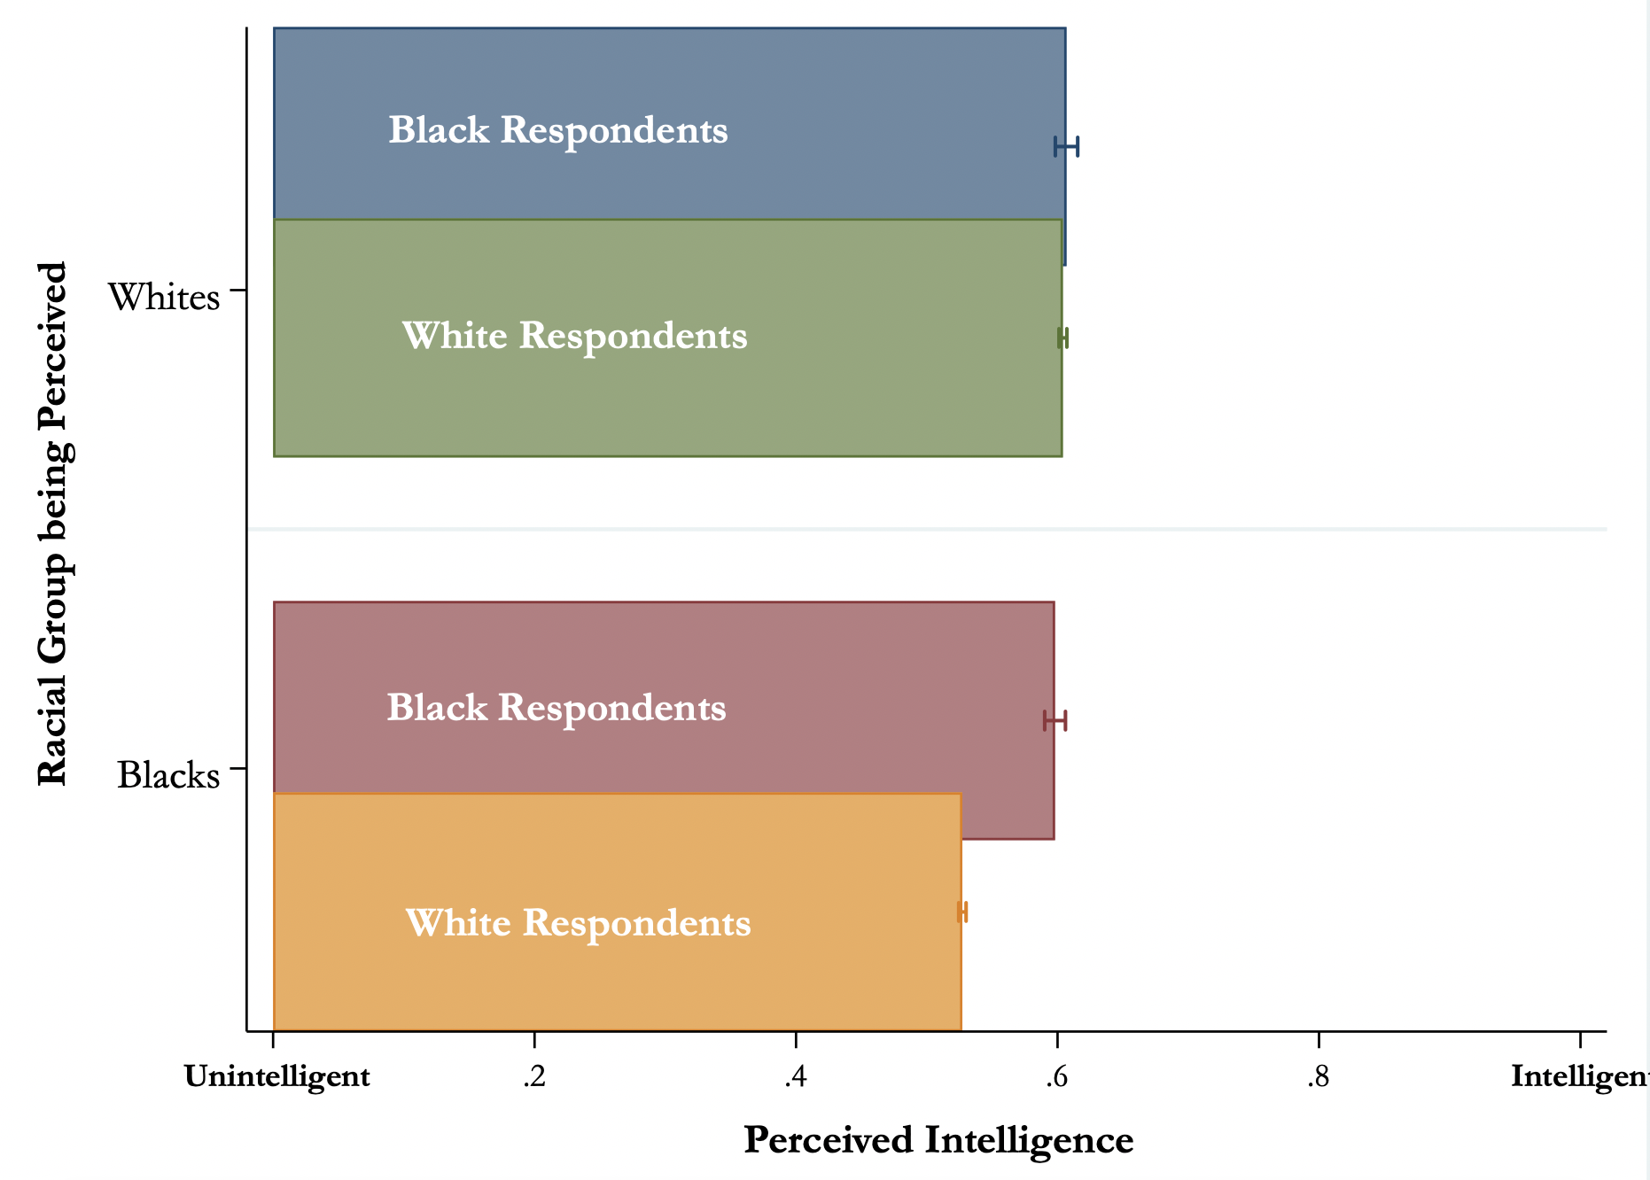
Source: Cumulative GSS
Figure 1. Perceptions of the Intelligence of Black and White people from White and Black Respondents
Relying on the cumulative General Social Survey to establish whether the stereotypes Black individuals have about White people are the traditional stereotypes of laziness and lack of intelligence that have been historically used against Black people. If my argumentation about the nature of Black people’s stereotypes is incorrect, we should expect to see that Black people’s assessments of White people’s intelligence (the upper row of the figure) to be significantly less than their assessment of Black respondents (the lower row of the figure). Instead, Figure 1 illustrates that, in the assessment of intelligence, Black respondents are fairly uniform in their assessment of White people and Black people's intelligence. In fact, they are also fairly uniform with White respondents in their assessment of Whites’ intelligence. Put another way, Black respondents believe White and Black people are equally as intelligent and White and Black respondents show no meaningful difference in how they perceive White people’s intelligence. These findings strongly affirm my contention that Black people have not adopted the traditionally studied stereotypes.
Furthermore, the findings presented also affirm the way White people assess intelligence depicting a statistically significant difference between Black respondents and White respondents’ assessment of Black people's intelligence (p<.00). White respondents perceive Black people to be much less intelligent than White people, which has been evinced in other scholastic works. Relative to Black respondents there is a clear and substantive decline in the perception of Black people’s intelligence (p<.00). Overall, these findings offer important implications for the differences in the stereotypes that Black and White people employ.

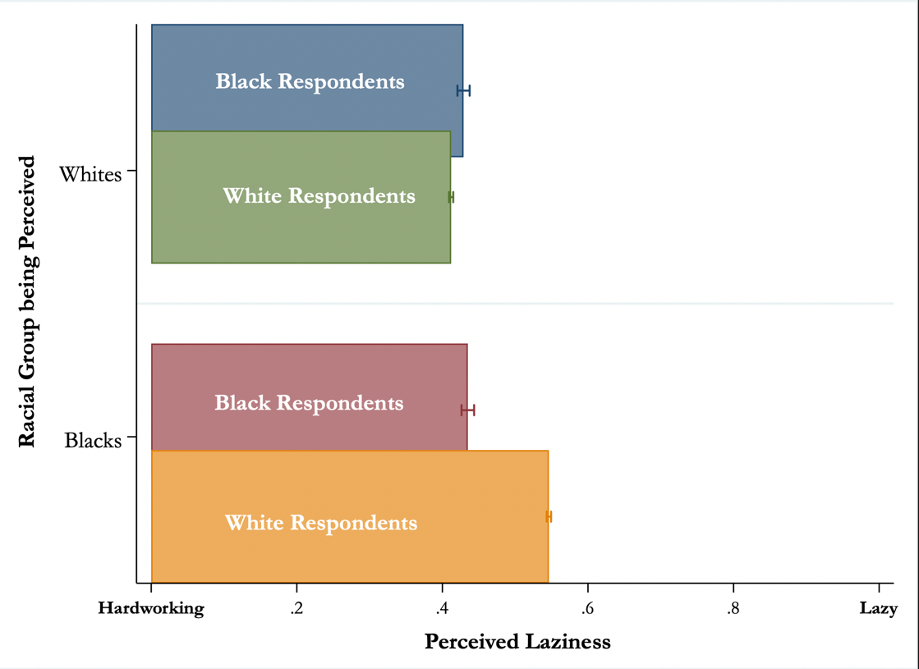
Source: Cumulative GSS
Figure 2. Perceptions of the Laziness of Black and White people from White and Black Respondents

Figure 2 provides further confirmation that Black people do not employ the same kinds of stereotypic beliefs about White people as are often used against them. In their assessments perceived laziness, we see that Black respondents are, relative to White respondents more likely to see White people as lazy (p<.00), which might lead one to believe that they are punishing White individuals, but there is no meaningful difference in Black respondents’ perception of Black people’s laziness relative to White peoples. This suggests that White respondents are simply evaluating themselves as more hardworking and not that Black respondents are claiming that White people are lazy. Inversely, relative to their perceptions of Black people, White respondents are much more inclined to perceive Black people as lazy relative to White people (p<.00) as well as relative to Black respondents who evaluate Black people. Again, there is evidence that Black people have not adopted the same stereotypes as their White counterparts.
While these findings provide important confirmation of my claim that Black and White rely on different stereotypes, they do not offer any sense of stereotypes Black people do have about White people. In order to better understand that, we turn to another dataset that asks Black people what they think White people think of them. This data was collected in 1991 by Time Magazine/CNN and offers a rare look at Black people’s perspectives of White people. Table 1 offers an overview of what percentage of Black respondents agree with the statement about the perceptions White people have about Black people.
Do you think that most white Americans hold the following perceptions of [B]lack Americans or not…
 | Yes | No | Not Sure
are lazy | 71 | 24 | 6
are religious | 62 | 29 | 9
are more likely to commit violent crimes | 84 | 11 | 5
would rather live off of welfare than work. | 78 | 16 | 6
are less intelligent than whites | 78 | 18 | 5
are better athletes than whites. | 78 | 16 | 7
have no self-discipline | 69 | 22 | 9
are patriotic | 43 | 46 | 11
have low moral standards | 75 | 19 | 7
are good parents | 38 | 51 | 11
are always whining about racism | 76 | 19 | 6
are more likely to abuse drugs and alcohol | 76 | 17 | 7
Source: 1991 CNN/Time Magazine Poll: Opinions of Black Americans
Table 1. Black perceptions of Meta-Stereotypes
The results in table 1 establish various meta-stereotypes and show Black people's beliefs about them. On a number of dimensions, a higher percentage of Black respondents believe that White individuals hold very negative views of them. More to the point, Black people are much less likely to think that White people believe the more positive perceptions such as being good parents and patriotic. This affirms the premise that Black people do have a picture of White people in their heads and that that picture is one that is framed through the lens of their belief about the racial animus Whites hold for them.
Prevalence of Discrimination | .13**  (.03)
Democrat | .00  (.05)
Constant | .69**  (.09)
R² | .09
N | 289
Table 2. Predicting Meta-stereotypes

Note: ** p<.01; * p<.05. Coefficients derived from an OLS regression model with controls for gender, education level, age, region, employment status, marital status, and income.
Source: 1991 CNN/Time Magazine Poll: Opinions of Black Americans
Part of my argument is that Black people’s belief about White people comes from their lived experiences with discrimination from White people. To better understand this particular relationship, I created a meta-stereotype composite variable of all the measures listed in Table 1 (alpha: .74), where 0 is the belief that White people hold positive views of them and 1is the belief that White people hold negative views of them. The results presented in Table 2 offer affirmation to my assertion that discrimination plays a prominent role in what informs Black people’s beliefs about these meta-stereotypes. The model shows that those individuals who believed that racial discrimination for Black people has become more prevalent were more likely to believe that white people had negative views of them than those who thought discrimination was less prevalent. This simple finding offers profound insights into what motivates Black people’s beliefs about White people. However, these results do not explain how Black people use this information in their navigation of certain contexts.
To shine a light on how context might influence how Black people use these stereotypes about White people, I return to the GSS and leverage the race of interviewer context. This method provides a novel way to establish whether or not black respondents are answering questions differently based on the race of the individual that they are being interviewed by. Scholarship on race of interviewer effects has shown that Black people are more inclined to change their responses based on who is interviewing them. In some cases, they change their answers to be more in line with what Black interviewers want from them (White & Laird 2020; Wamble et al 2022). In others, Black respondents will alter their responses to be seen as less stereotypic (Davis 1997). I contend that these changes indicate Black people’s understandings of what is expected of them based on their understanding of the context, and altering their behavior as a result.
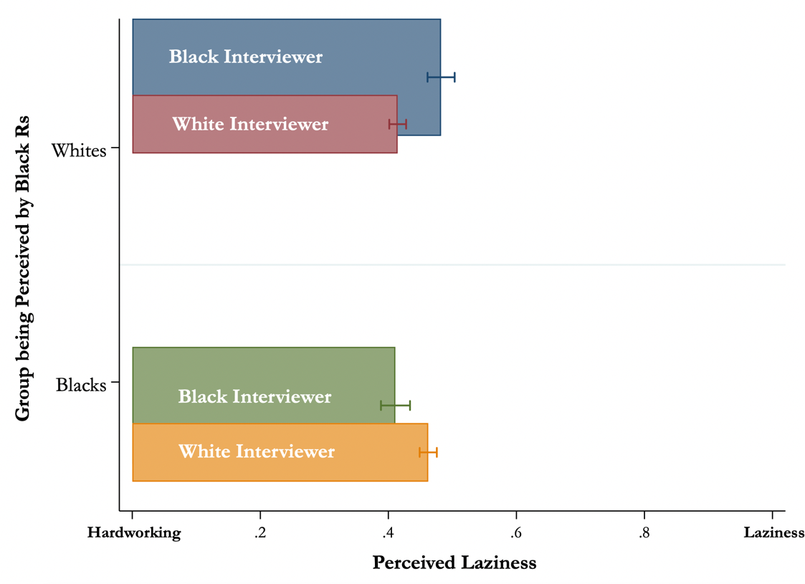
Source: Cumulative GSS
Figure 3. Race of Interviewer Effect on Perceptions of the Laziness of Black and White people from Black Respondents

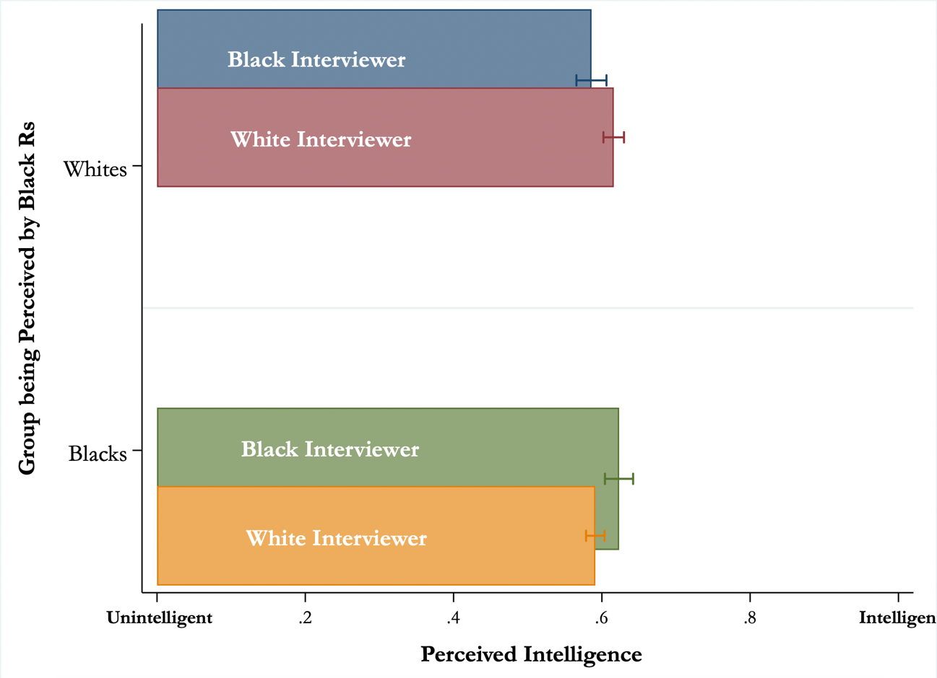
Source: Cumulative GSS
Figure 4. Race of Interviewer Effect on Perceptions of the Intelligence of Black and White people from Black Respondents
In Figures 3 and 4, it is clear that Black respondents are more likely to be complimentary in their assessments of White people when they are interviewed by a White person, both in their perceptions of intelligence and laziness (p<.00). One could posit that perhaps Black respondents are simply meeting the expectations of Black interviewers by being perceiving White individuals negatively, which is what leads to the meaningful difference between those interviewed by Black versus White interviewers. While it is difficult to categorically rule out that possibility, the findings presented in figures 1 and 2 offer compelling evidence that Black respondents do not hold drastically negative views of White people with regard to these stereotypes. This means that they are less likely to feel compelled to prove something to their Black interviewer as the norms and expectations of the racial group, which have been shown to be important considerations (see White and Laird 2020), are less defined in terms of their overall sentiments of White people.
Interestingly, Black respondents who were interviewed by a White interviewer, relative to those with a Black interviewer, are more likely to provide answers that suggest that Black people are lazy and less intelligent (p<.00). I posit, that Black people leverage their awareness of White people’s biases towards them and offer them the answer they believe they want to hear. There is little to no incentive to over claim their perception of these stereotypes with Black interviewers, but literature on race of interviewer effects and stereotype threat (Davis and Silver 2003) suggest that this context might cause Black individuals to change their responses in ways that would be in line with the stereotypes held against them.
Overall, these findings confirm my expectations about what stereotypes Black people have and the way that they use them. The results presented through this work show that black people approach stereotypes about white people differently than white people approach it about black people. Black people use their experiences of discrimination as a way to be able to recognize this as a way to figure out white people and white people's behaviors and white people's perceptions of them. Black people are using stereotypes as a way to figure out how to navigate white spaces and white people and behave in ways that are more in line with the way that they think white people want them to behave to survive. The origin story of these stereotypes is one of survival, and because of that black people have to figure out how to navigate white spaces so that they can effectively garner progress but also be able to just live.

Discussion & Conclusion

The influence of the Black electorate has grown considerably over time, particularly within the Democratic Party. While Black individuals have had to vote for a significant number of white politicians, very little is known about why they vote for certain white politicians. However, we have a strong understanding of why white individuals vote for Black politicians, as racial stereotypes are a meaningful political tool that informs how they view politicians and policy platforms. It is imperative to understand the stereotypes that Black people have about white people, and White politicians by extension, given the frequency with which they vote for these individuals and the policy implications of their potential platforms. This work provides the first step in understanding the meaningful political implications of stereotypes that Black people hold about white individuals. White people's stereotypes about Black politicians and policies stem from existing social stereotypes that they hold about Black people. Therefore, to understand how Black individuals think about white politicians, we must first understand what they think about and navigate the political choices of white people.
Part of the reason Obama was able to garner success with Black voters in 2008 was his success in Iowa, a very White state. Prior to his success there, Hillary Clinton had amassed the support of Black individuals, leaders and voters alike. I contend that Black individuals were concerned that, based on their general belief that white people hold prejudiced views towards Black people, they would need strong evidence on the part of White people that they would be willing to support a Black man for president. The findings in this work show that Black individuals approach stereotypes by thinking about their own experiences with White people, and not through the fabrication of a different narrative to gain the social upper hand or maintain the racial hierarchy. However, in politics, it is imperative to understand these stereotypes, as they have important implications for the potential success of white politicians. In addition to expanding understandings of Black people’s views of white individuals, this research offers a framework through which to understand how other marginalized groups might hold stereotypes about dominant groups in their respective social identity categories. It provides a baseline to understand how White politicians might overcome these stereotypes.
It is important to understand exactly what marginalized groups think about the dominant group as, particularly in politics, they have to make choices that involve them. Scholastic understanding of these interpersonal relationships, and the subsequent political implications, tend to be wrapped up in our understanding of how these groups understand one another. Scholarship has focused on the way that the dominant population views marginalized populations, but marginalized groups have also come up with stereotypes to navigate the dominant group and alter their own behaviors.

Bibliography
- Anderson, Elijah. Black in white space: The enduring impact of color in everyday life. University of Chicago Press, 2022.
- Bonilla-Silva, E. (1997). Rethinking racism: Toward a structural interpretation. American Sociological Review, 62(3), 465-480.
- Brown, Nadia E., and Danielle Casarez Lemi. Sister style: The politics of appearance for Black women political elites. Oxford University Press, 2021.
- Davis, Darren W. "The direction of race of interviewer effects among African-Americans: Donning the black mask." American Journal of Political Science (1997): 309-322.
- Davis, Darren W., and Brian D. Silver. "Stereotype threat and race of interviewer effects in a survey on political knowledge." American Journal of Political Science 47, no. 1 (2003): 33-45.
- Dawson, M. C. (1994). Behind the mule: Race and class in African-American politics. Princeton University Press.
- Dolan, K. (2010). The impact of gender stereotypes on the evaluation of female political candidates. Political Psychology, 31(5), 1-16.
- Dovidio, J. F., & Gaertner, S. L. (1986). Prejudice, discrimination, and racism: Historical trends and contemporary approaches. Law & Society Review, 20(1), 1-39.
- Stephens-Dougan, LaFleur. Race to the bottom: How racial appeals work in American politics. University of Chicago Press, 2020.
- Fiske, S. T., Cuddy, A. J., Glick, P., & Xu, J. (2002). A model of (often mixed) stereotype content: Competence and warmth respectively follow from perceived status and competition. Journal of Personality and Social Psychology, 82(6), 878-902.
- Gilens, M. (1996). Racial attitudes and opposition to welfare. Journal of Politics, 58(2), 189-220.
- Hopkins, D. J. (2010). Politicized places: Explaining where and when immigrants provoke local opposition. American Political Science Review, 104(1), 40-60.
- Jacobsmeier, M. L. (2015). Race and candidate evaluation in the 2012 presidential election: An examination of the effects of skin tone, linked fate, and racial attitudes. Politics, Groups, and Identities, 3(1), 1-19.
- Jones, Philip Edward. "Revisiting stereotypes of non-white politicians’ ideological and partisan orientations." American Politics Research 42, no. 2 (2014): 283-310.
- Kalla, J. L., & Broockman, D. E. (2018). Campaign contributions facilitate access to congressional officials: A randomized field experiment. American Journal of Political Science, 62(1), 1-17.
- Krupnikov, Yanna, and Spencer Piston. "Racial prejudice, partisanship, and white turnout in elections with black candidates." Political Behavior 37 (2015): 397-418.
- Laird, Chryl. "Black like me: How political communication changes racial group identification and its implications." Politics, Groups, and Identities 7, no. 2 (2019): 324-346.
- Lippmann, W. (1922). Public opinion. Harcourt, Brace and Company.
- Mendelberg, T. (2001). The race card: Campaign strategy, implicit messages, and the norm of equality. Princeton University Press.
- Peffley, M., & Hurwitz, J. (1998). Public perceptions of race and crime: The role of racial stereotypes. American Journal of Political Science, 42(2), 375-401.
- Pew Research Center. (2021, January 4). Diversity in the 117th Congress. Pew Research Center Fact Tank. https://www.pewresearch.org/fact-tank/2021/01/04/diversity-in-the-117th-congress/
- Raphael, C., & Stoll, M. A. (2010). The political economy of racial disparities in preterm birth. Social Science & Medicine, 71(1), 210-218.
- Schneider, Monica C., and Angela L. Bos. "An exploration of the content of stereotypes of black politicians." Political Psychology 32, no. 2 (2011): 205-233.
- Sears, D. O., & Henry, P. J. (2003). The origins of symbolic racism. Journal of Personality and Social Psychology, 85(2), 259-275.
- Sigelman, L., Sigelman, C. K., Walkosz, B. J., & Nitz, M. (1995). Black candidates, White voters: understanding racial bias in political perceptions. American Journal of Political Science, 39(1), 243-265.
- Sigelman, Lee, and Steven A. Tuch. "Metastereotypes: Blacks' perceptions of Whites' stereotypes of Blacks." The Public Opinion Quarterly 61, no. 1 (1997): 87-101.
- Terkildsen, N. (1993). When White voters evaluate Black candidates: The processing implications of candidate skin color, prejudice, and self-monitoring. Public Opinion Quarterly, 57(3), 324-347.
- Wamble, Julian J., and Chryl N. Laird. "The power of post-racial: an exploration of post-racial rhetoric’s influence on candidate evaluations." Politics, Groups, and Identities 8, no. 3 (2020): 515-534.
- White, Ismail K., and Chryl N. Laird. "Steadfast democrats." In Steadfast Democrats. Princeton University Press, 2020.

